**CHAPTER 1**

**INTRODUCTION**

The technological advancements have significantly impacted our lives. Tasks like shopping, booking movie tickets, or marketing, can now be easily done from the comforts of your home. There are now online portals that allow you to buy anything in a simple and hassle-free manner.

The objective of this project is to deliver the above mentioned functionalities to a user, which in this case, is booking tickets for Indian Super League in comfort of their own homes. Any user can buy tickets for their preferred matches without standing in long queues.

This desktop application comprises of two platforms, NetBeans IDE (Java) and MySQL (DBMS). The two platforms are connected using a JDBC driver which acts as a bridge between the two platforms. Using the database management system we can efficiently store and retrieve data as per our convenience.

**CHAPTER 2**

**SYSTEM REQUIREMENTS**

**Hardware Requirements**

* Processors : Pentium IV
* Processor Speed : 3.00 GHZ
* RAM : 2 GB
* Storage : 20 GB
* Monitor : 15 inches
* Keyboard : Standard 102 keys
* Mouse : Standard 3 buttons

**Software Requirements**

* Operating System: Windows.
* NetBeans IDE 8.2
* MySQL Server 5.0
* Mysql-connector-java-5.0.8
* Other required software packages and tools are included within the project folder.

**CHAPTER 3**

**DESIGN**

**3.1 Entity-Relationship (ER) Diagram**

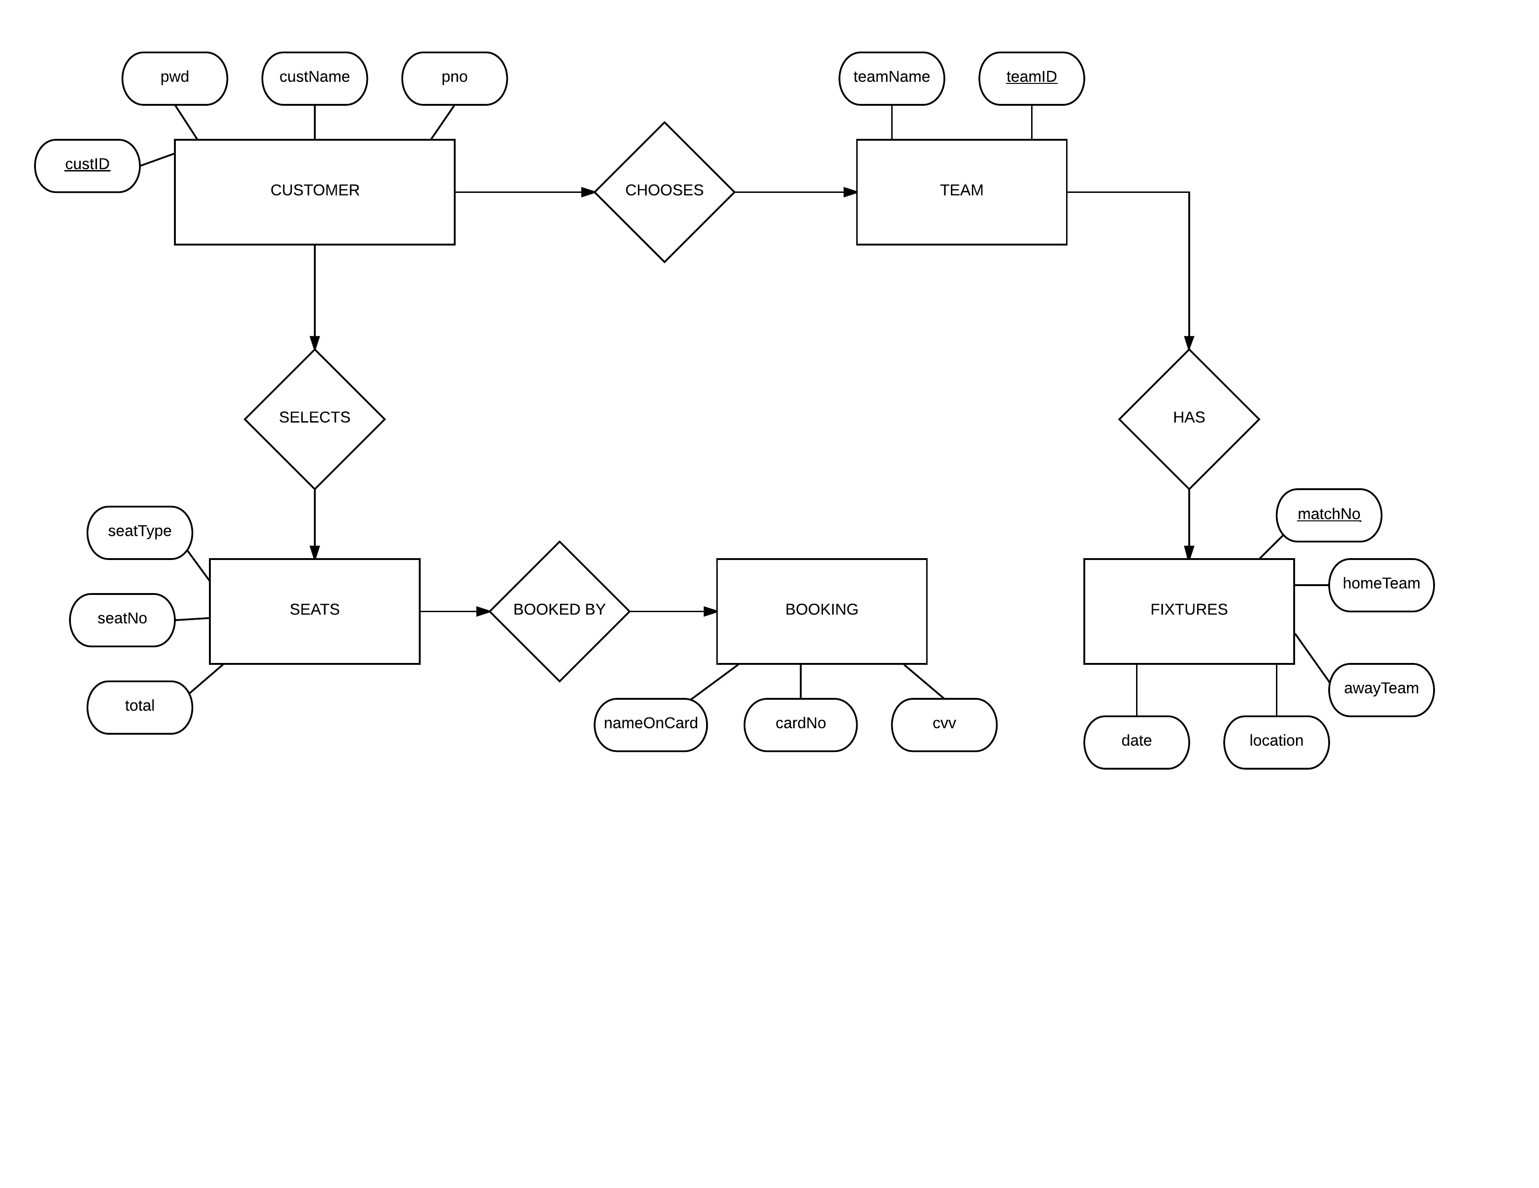

**3.2 Relational Schema Diagram**

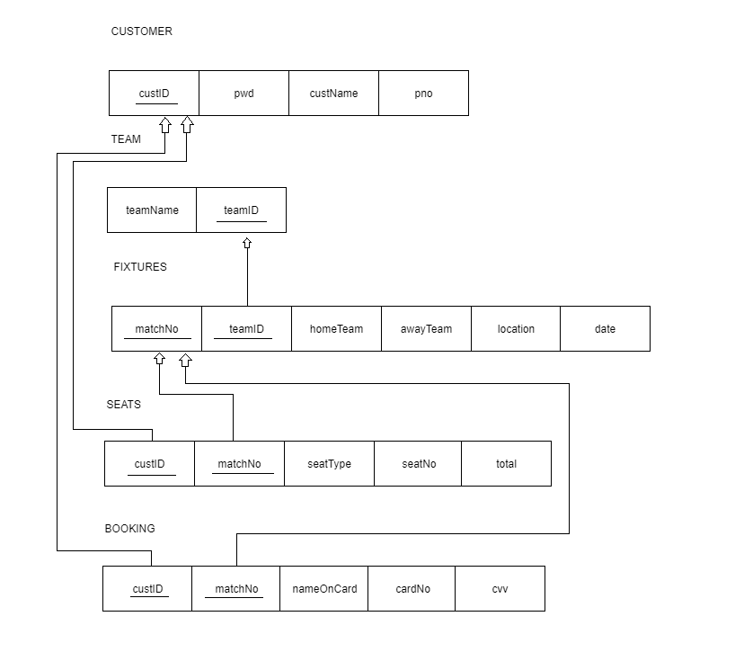

**3.3 Use Case Briefs**

**User / Buyer**

|  |  |  |  |
| --- | --- | --- | --- |
| **Action** | **Objective** | **Description** | **Failure** |
| **Login to a User Account** | Login to an already existing user account to continue to next form and book tickets. | We obtain the user ID and the password and check with existing records. | Using wrong details which are not matching existing user information. |
| **Sign up for a User Account** | Register a unique user ID, password and phone number. | We obtain the required, basic information of the user. | Using an already existing user ID linked to another user. |
| **Check Status** | A list of tickets already booked by a user. | Helps the user to keep track of the tickets that have been already bought. | No specific cases in particular |

**CHAPTER 4**

**IMPLEMENTATION**

**4.1 OVERVIEW OF NETBEANS**

NetBeans is a software development platform written in Java. The NetBeans Platform allows applications to be developed from a set of modular software components called modules. Applications based on the NetBeans Platform, including the NetBeans integrated development environment (IDE), can be extended by third party developers.

Design GUIs for Java SE, HTML5, Java EE, PHP, C/C++, and Java ME applications quickly and smoothly by using editors and drag-and-drop tools in the IDE.

Netbeans is popular due to its GUI builder which allows user to make the user interface easily. With options of drag and drop anyone can make modules on Netbeans. Hence it’s a powerful IDE.

**4.2 Login form**

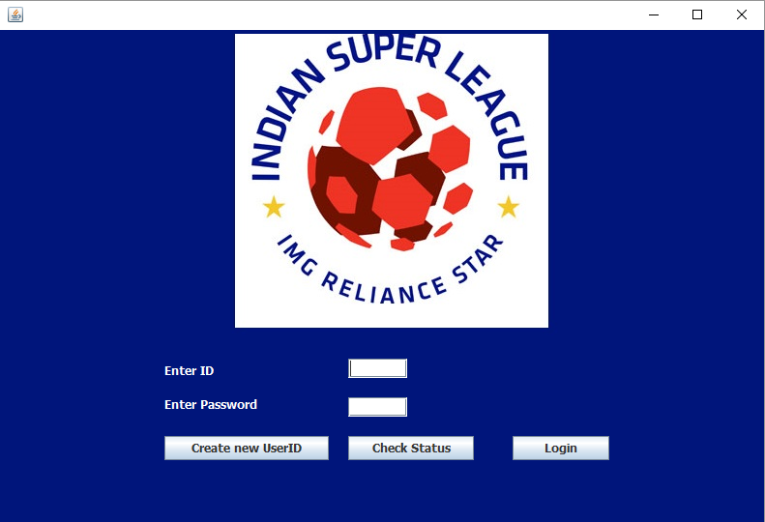

**Fig 4.2.1 Login form**

The above image depicts the login form of the project. It takes the user ID and password from the user in the textfields t1 and t2 respectively.  
There are three buttons on the login form. They are:

* Create new userID
* Check status
* Login

**4.2.1 Login form Source code**

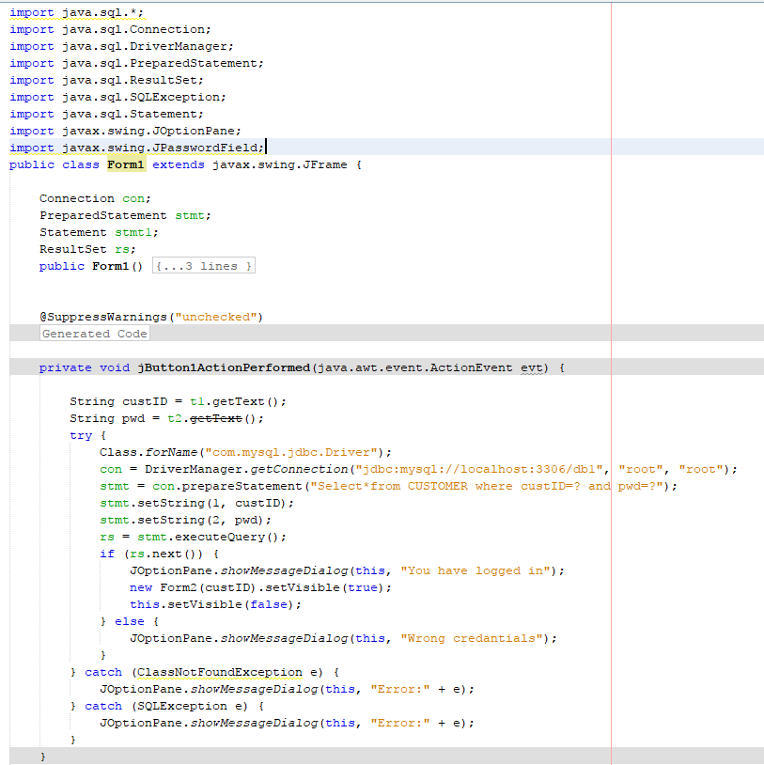

**Fig 4.2.2 Login form source code**

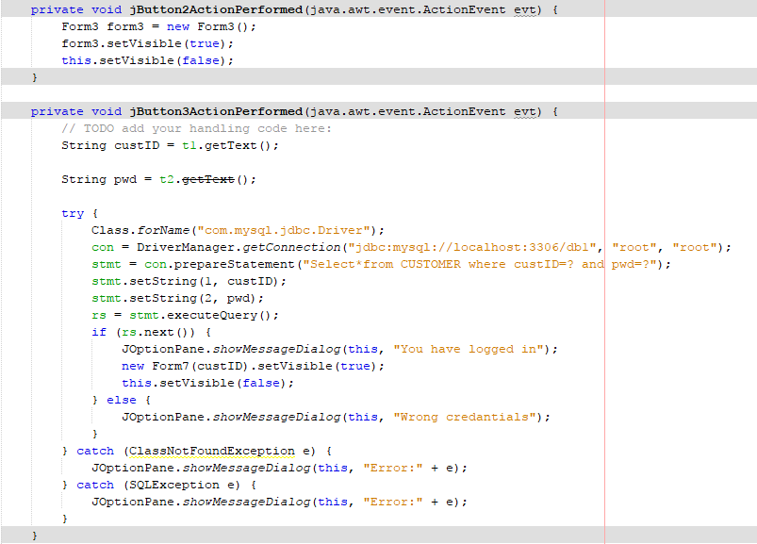

**Fig 4.2.3 Login form source code**

**4.3 Registration form**

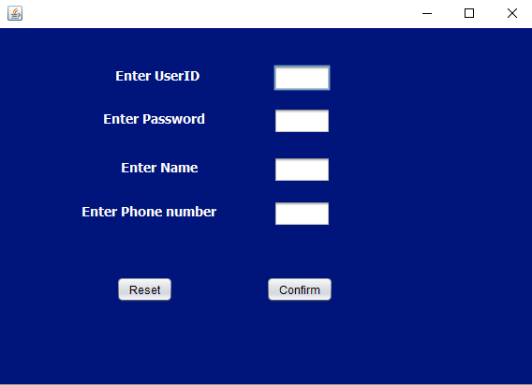

**Fig. 4.3.1 Registration form**

This form is opened when the user clicks on create new user ID on Login form. This form takes inputs from the user and stores it the DBMS.

**4.3.1 Registration form source code**

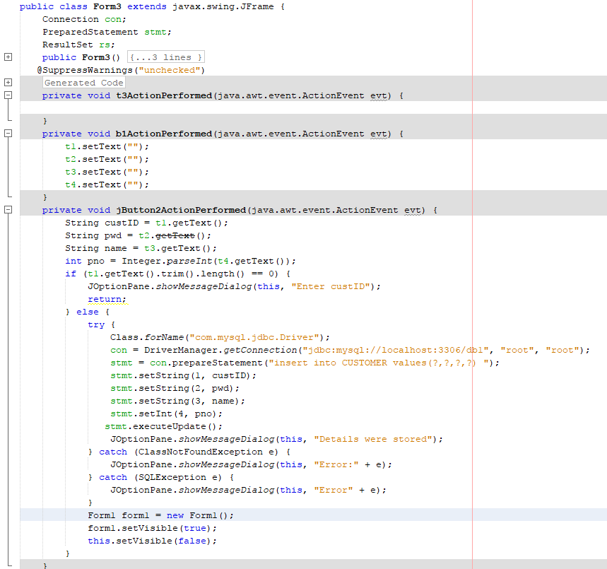

**Fig 4.3.2 Registration form source code**

**4.4 Team form**

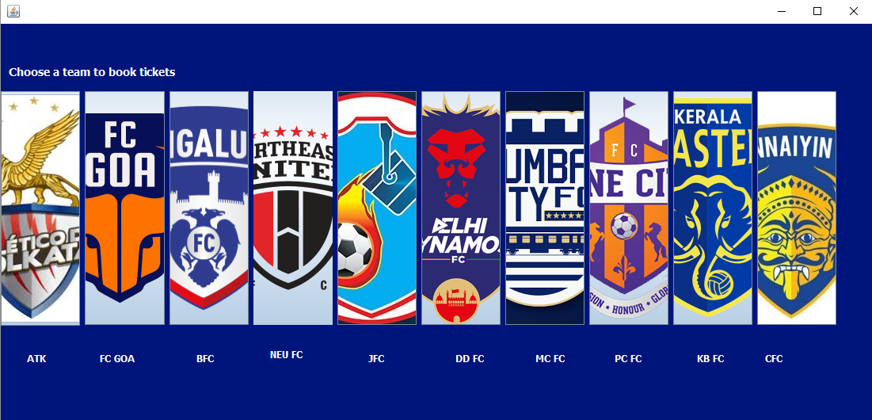

**Fig 4.4.1 Team form**

After successfully logging in with your user ID and password, the team form is opened. Here the user has the option to choose the team for which they want to book tickets. By default the home location will be set to the respective team’s home location.

Clicking on any team’s logo , the fixtures form would open which would show the fixtures of the chosen team with its logo and name.

**4.4.1 Team form source code**

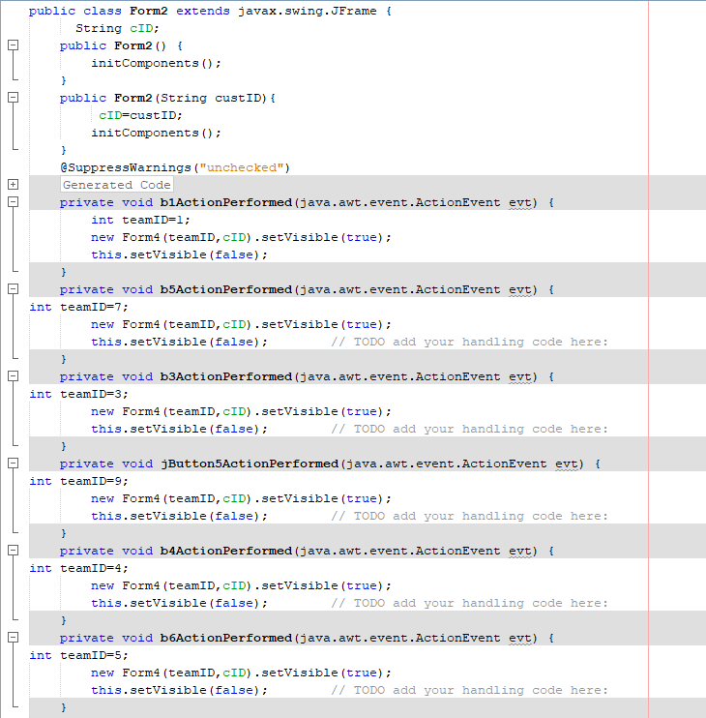

**Fig 4.4.2 Team form source code**

**4.5 Fixtures form**

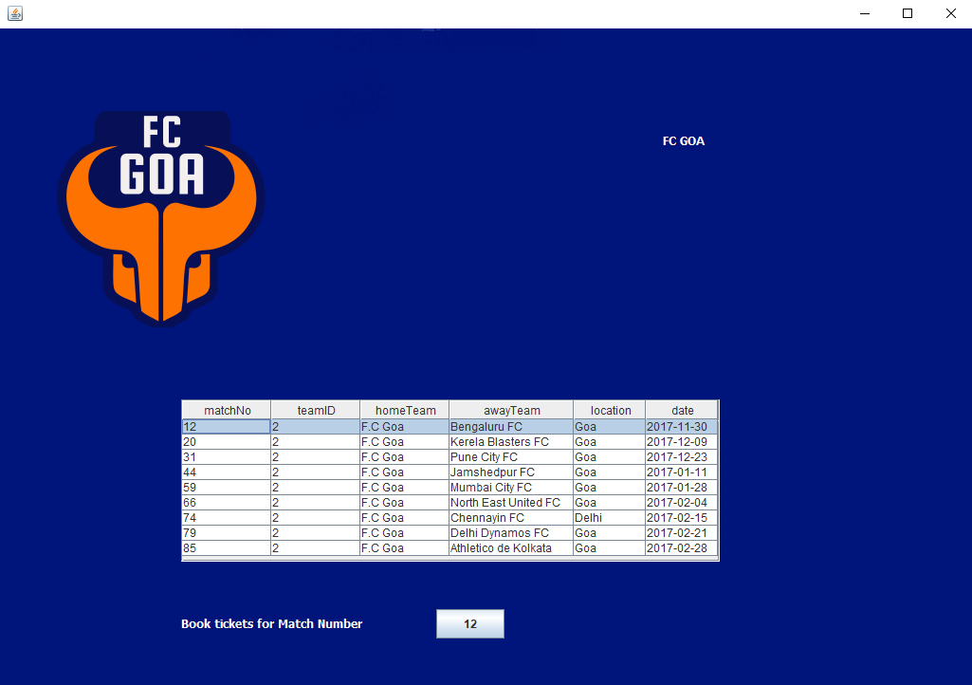

**Fig 4.5.1 Fixtures form**

By clicking on the logo of any team Fixtures form is opened. In the above example, the user chose FC GOA. Therefore the form shows the logo, name and fixtures of the team FC GOA.

The user can book the ticket after selecting the match on the table.

**4.5.1 Fixtures form source code**

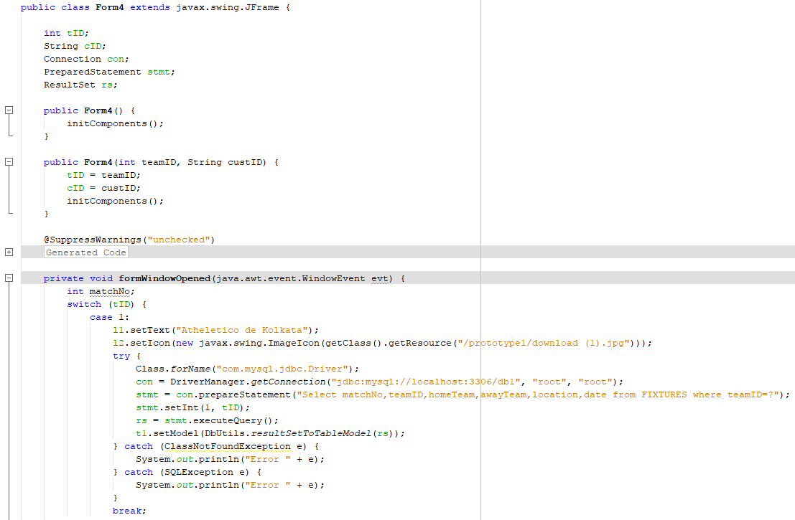

**Fig 4.5.2 Fixtures form source code**

Using switch case, different team’s logo, name and fixtures would be opened. In our case the team selected was FC GOA; hence its logo, name and fixtures were displayed on the form.

**4.6 Seats Form**

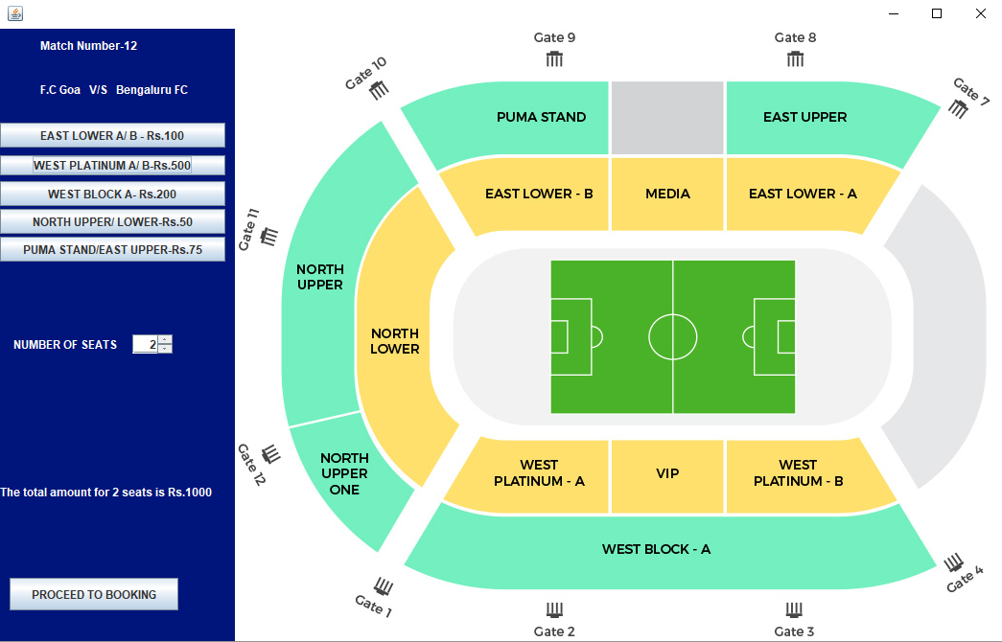

**Fig 4.6.1 Seats form**

Upon clicking the book button on Fixtures form, the seats form is opened depicts the match number chosen , the two teams playing and the seats as shown in the figure. Using the spinner the user can choose upto 10 seats and upon clicking the type of seats , a label would show the total amount before proceeding.

**4.6.1 Seats form source code**

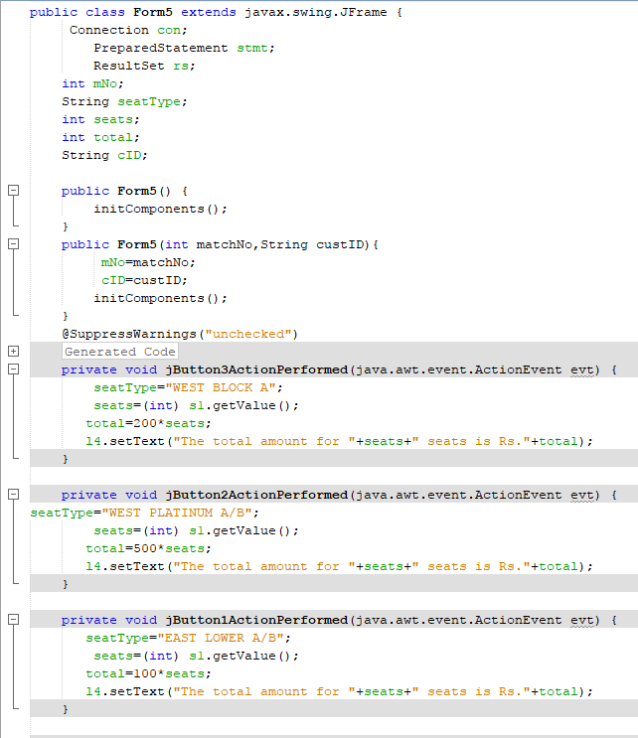

**Fig 4.6.2 Seats form source code**

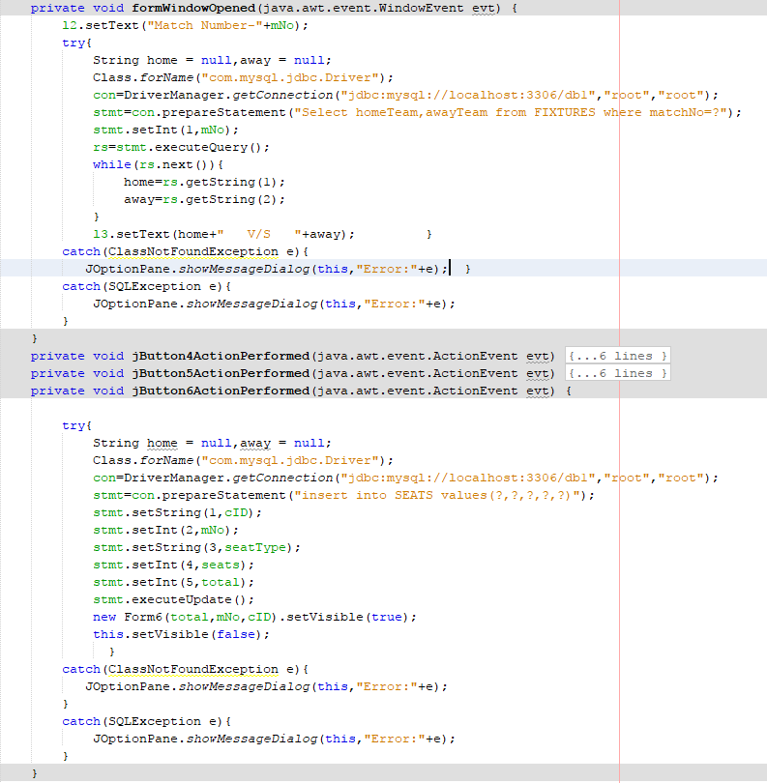

**Fig 4.6.3 Source code**

**4.7 Booking form**

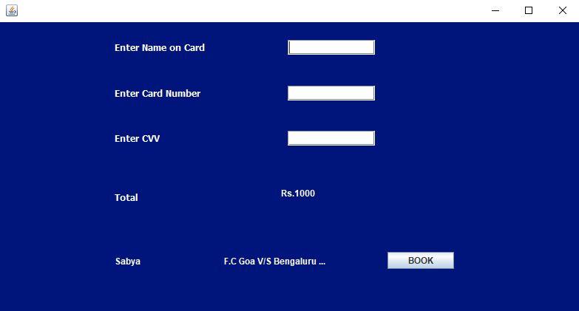

**Fig 4.7.1 Booking form**

The booking form is opened when the users chooses proceed to booking on Seats form. It displays the customer name, the two teams playing the match and the total amount. The user’s bank details are stored.

**4.7.1 Booking form source code**

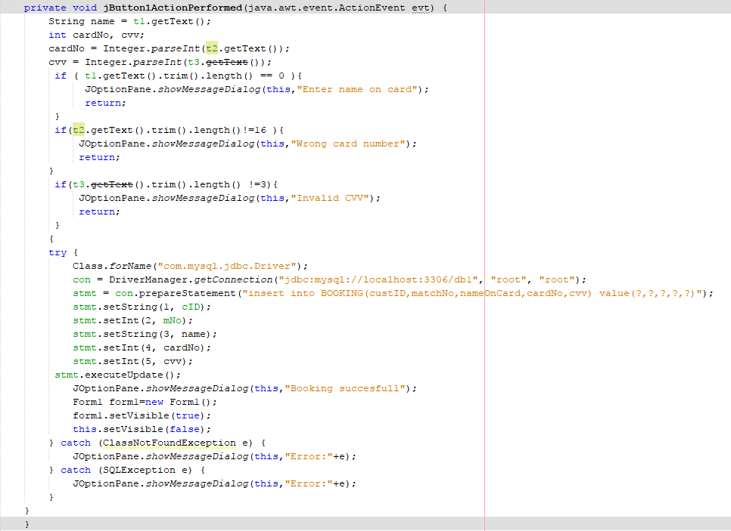

**Fig 4.7.2 Source code**

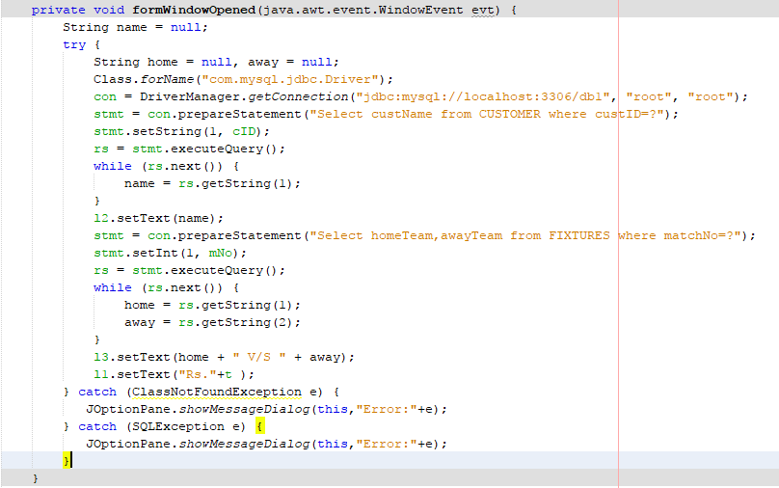

**Fig 4.7.3 Source code**

Once the details are stored, a message is shown on the screen and Login form is opened again. The user can check the status by entering his details and click on the button check status.

**4.8 Check status form**

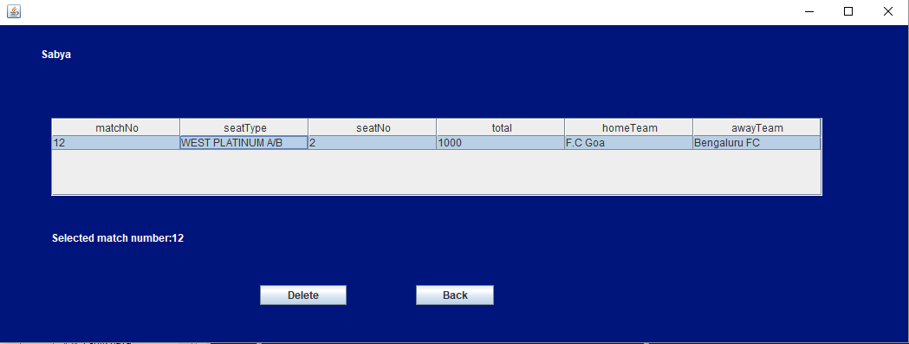

**Fig 4.8.1 Check Status form**

Upon clicking the check status form on the login form, the check status form is opened. On opening it will display the user’s name and the seats booked by the user.

If the user wishes to cancel the booking, he may click on the match and delete it using the delete button.

**4.8.1 Check status form source code**

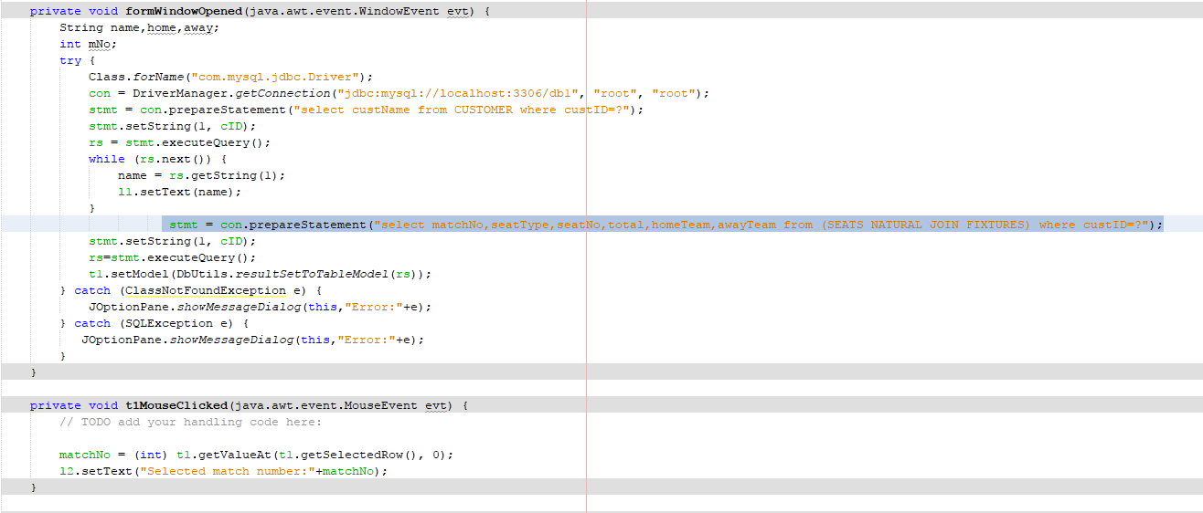

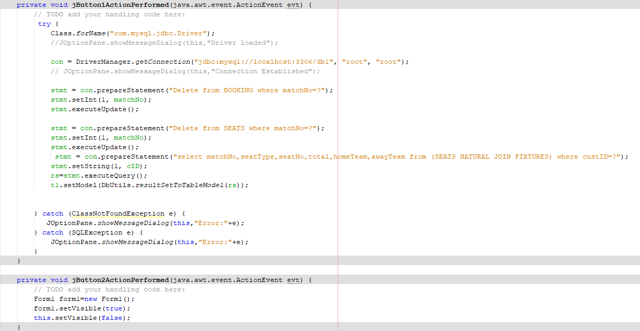

**Fig 4.8.2 Check Status source code**

**CHAPTER 5**

**CONCLUSION AND FUTURE SCOPE**

The Internet has become a major resource in modern business, thus electronic shopping

has gained significance not only from the entrepreneur’s but also from the customer’s

point of view. For the entrepreneur, electronic shopping generates new business

opportunities and for the customer, it makes comparative shopping possible. As per a

survey, most consumers of online stores are impulsive and usually make a decision to

stay on a site within the first few seconds. “Website design is like a shop interior. If the

shop looks poor or like hundreds of other shops the customer is most likely to skip to the

other site”. Hence we have designed the project to provide the user with easy navigation,

retrieval of data and necessary feedback as much as possible.

In this project the user is provided with a platform to book tickets at their convenience using a simple program. To implement this we have used NetBeans IDE as its parent framework. The backend data storage was done using MySQL server 5.0.

This project helps in understanding the creation of an interactive desktop application and the

technologies used to implement it. The design of the project includes an ER diagram,

which we used to decide how the user data and fixtures should be stored in

our database. The ER diagram was further mapped to a Relational Schema, to implement

the designed model into a relational database. We also designed Use Case Briefs for the

user to be clear about the features our application must implement.

Building this project has given me a precise idea on how to go about building a

desktop application using the knowledge we’ve obtained.

**Future Scope**

The project can be further improved to by including the following during future

Development:

* The Website is not accessible to everyone. It can be deployed on a web server so that

everybody who is connected to the Internet can use it.

* A payment gateway can be implemented to accept payments from users, using third

party application APIs.

* Multiple carts functionality can be implemented for each user.
* APIs for the project can be developed, and supplied to third-party developers, for

further development.

**BIBLOGRAPHY**

[1] https://stackoverflow.com/

[2] https://netbeans.org/

[ 3 ] https://dev.mysql.com/doc/

[ 4 ] https://www.w3schools.com/

[ 6 ] https://www.youtube.com/user/sentdex

[ 7 ] https://www.youtube.com/user/thenewboston